Conic Sections
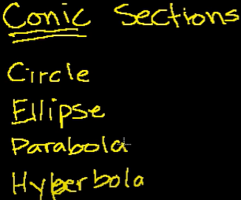
They are called conic sections, because they are the intersection of a plane and a cone.

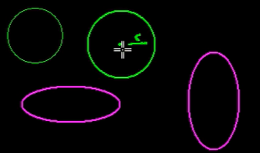
Circle and elipse are special case. Where Circle is a special case of elipse where its not stretched in one direction more than other. Its perfectly symmetrical.

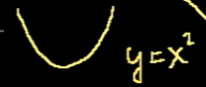
Parabola

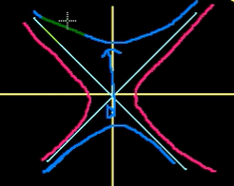
Hyper bola, you have 2 asymptotes.
Vertical or horizontal hyperbola.

Why its called conic sections?
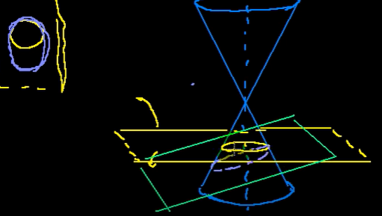

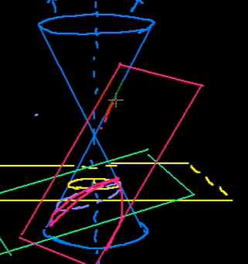
Parabola
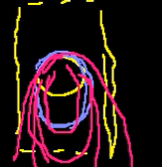

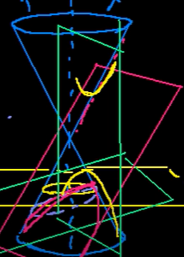
Yoy get a hyberbola

Features of circle from standard equation
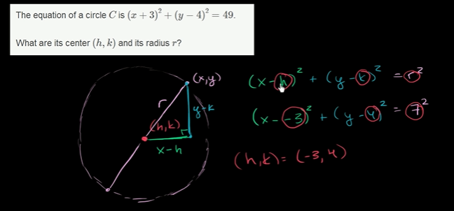

Features of circle from expanded equation
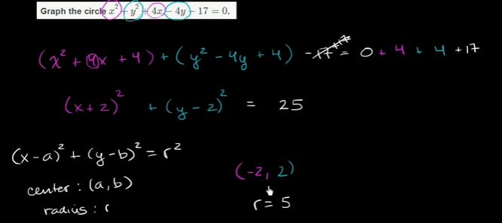

Intro to focus and directrix of a Parabola
Parabolas: Focus , directrix
Parabolas can be defined as a set of all points that are equidistant to a point and a line.
The point is the focus of the parabola, the line is the directrix of parabola.
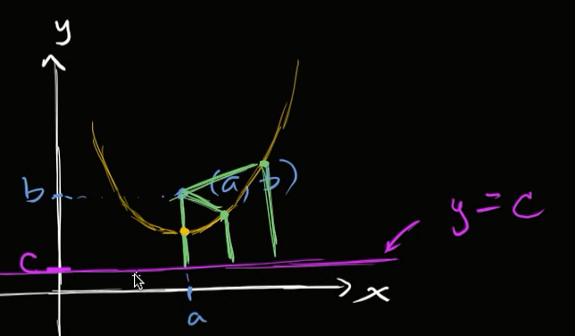
Here, any point in parabola, the distance from focus to the point is equal to the Straight line distance on directrix.
Essentially a perpendicular.

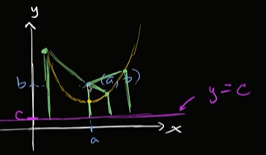
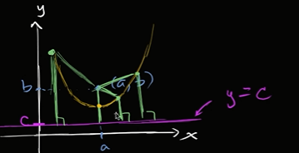

Equation of a parabola from focus & directrix
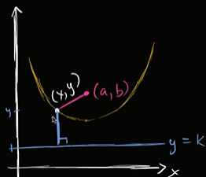
You can definitely have a parabola , where y-coordinate of focus is lower than y-coordinate of directrix.

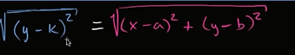

sq.rt((y-k)^2) is done only to take absolute value.
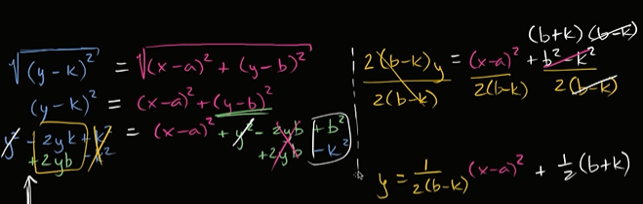
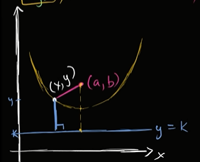
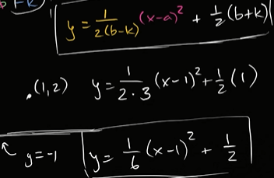

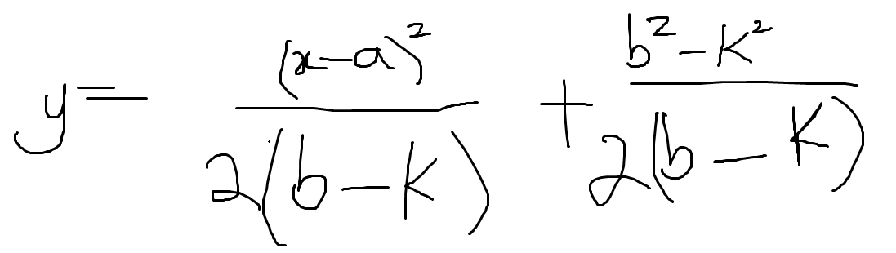

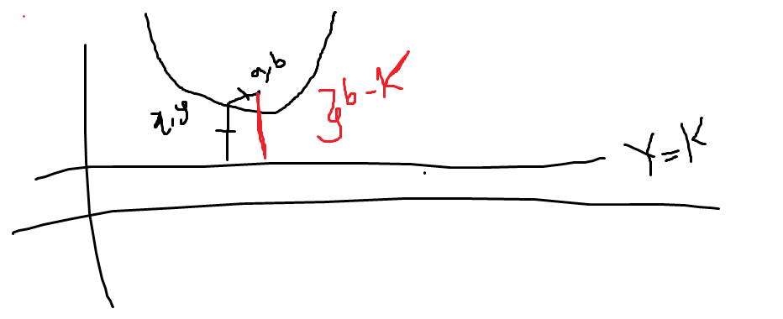

Precalculus > Conic sections >

Center and radii of ellipse

Intro to ellipses
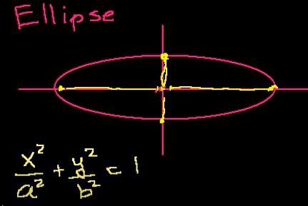
Here a is the length of the radius in the x-direction.

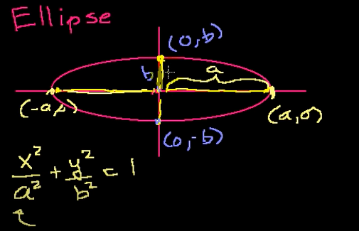
We have drawn, short and fat ellipse. We can also draw a tall and skinny ellipse.
In short and fat ellipse, the direction you short in, is called minor axis.
The direction you fat in, is called major axis.
Small b is called the semi minor axis.
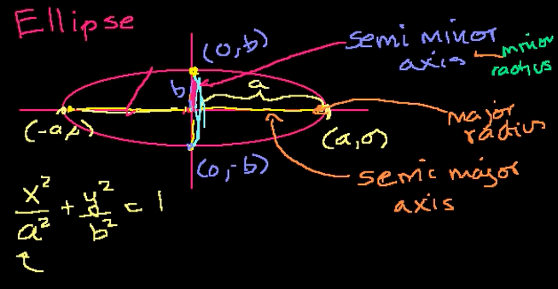

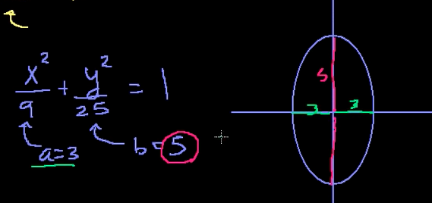

Shifting the origin by 5 units to the right.
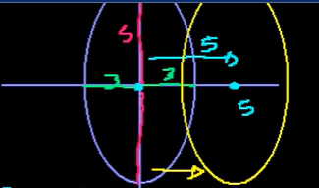
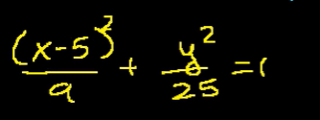

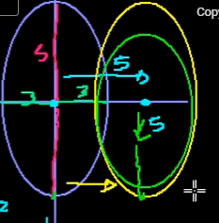
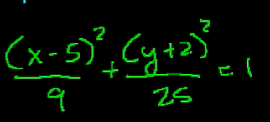

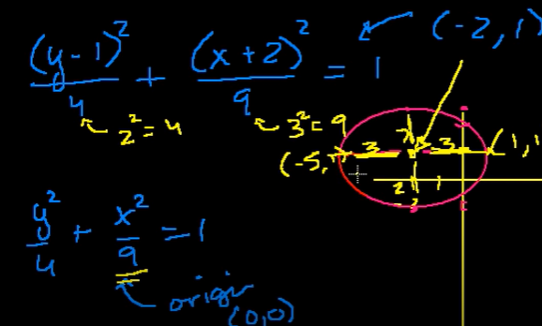
Center is at -2,1.
Small a,b is 3,2
so sal draw (-5,1) and (1,1) By
(-2-3,1), (-2+3,1)
(-5,1),(1,1)

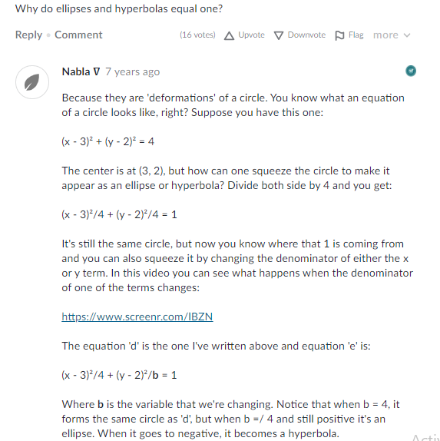

Foci of an ellipse

Foci of an ellipse from equation
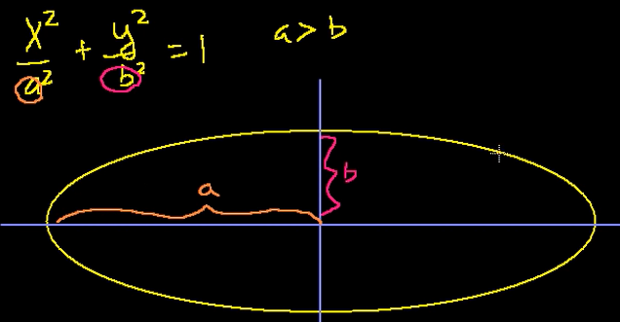
If you take any point on the ellipse and measure the distance from that point to two special points.
These two points always sit on the major axis and they symmetric around the center of the elipse.

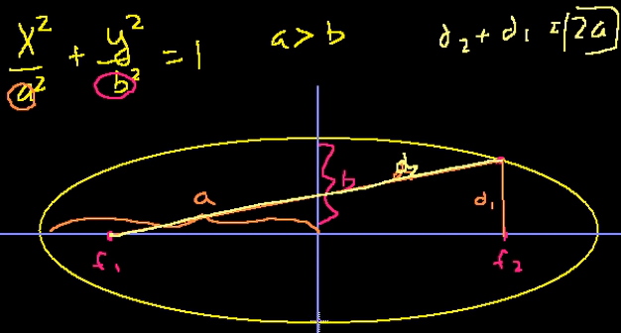

Ellipse is a set of all points(locus) where sum of the distances from each of the two focuses is equal to a constant.
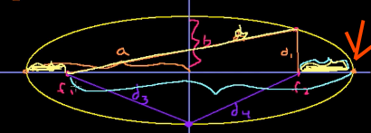

f1+f2=2a.

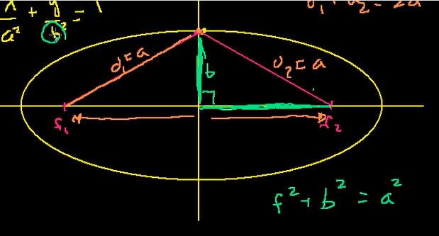

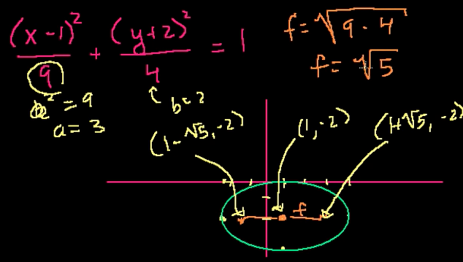

Introduction to hyperbolas

Intro to hyperbolas
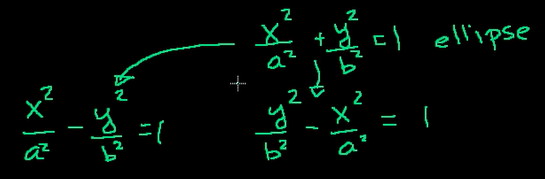

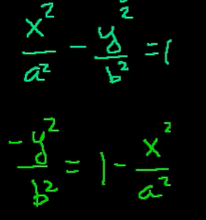
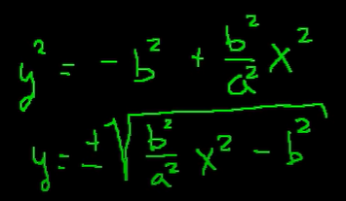

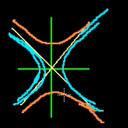

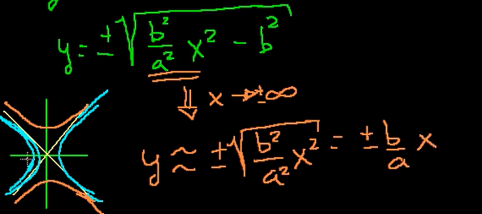

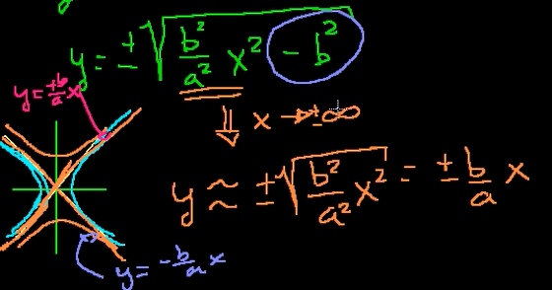

You could never have x=zero.

You can have y=0 but.
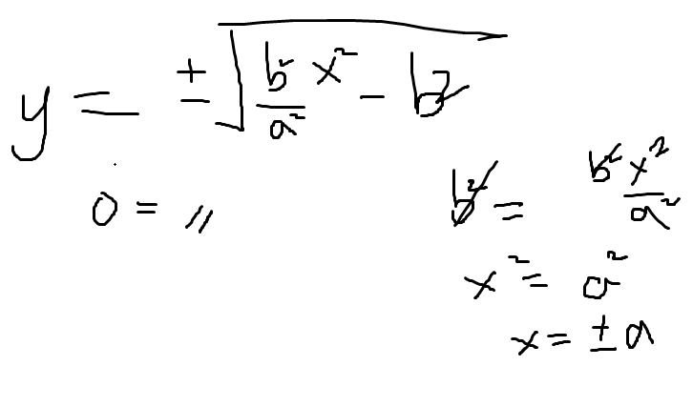
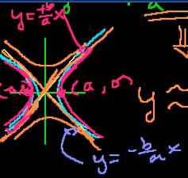

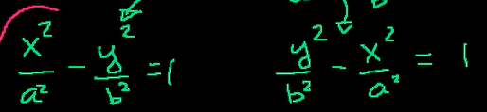

When x term was postive hyperbola open right and left.
So when the y-term is postive we would be open up and down.
Or
You simply try out, for the 1st eq , if x is zero, y is imaginary.
Which means left and right open hyperbola.
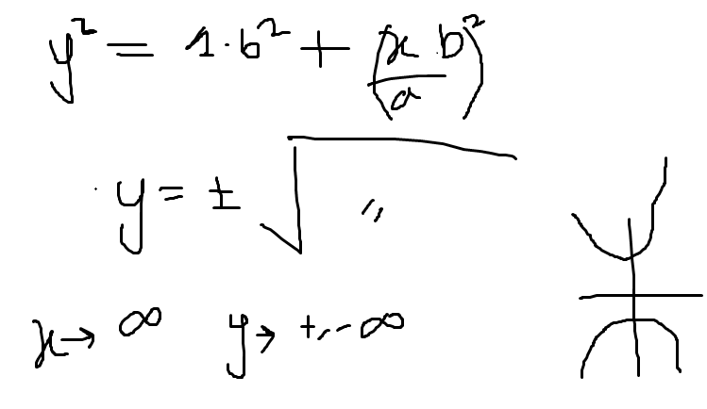

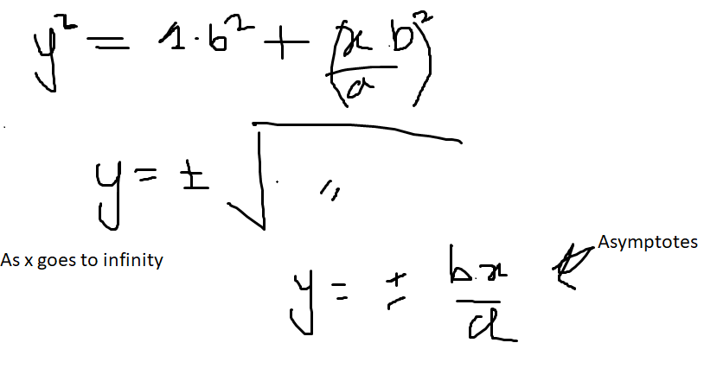

Vertices and direction of a hyperbola
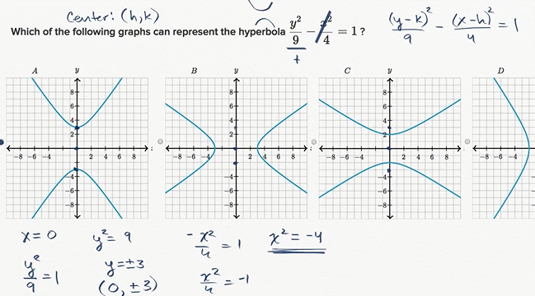

Vertices and direction of a hyperbola
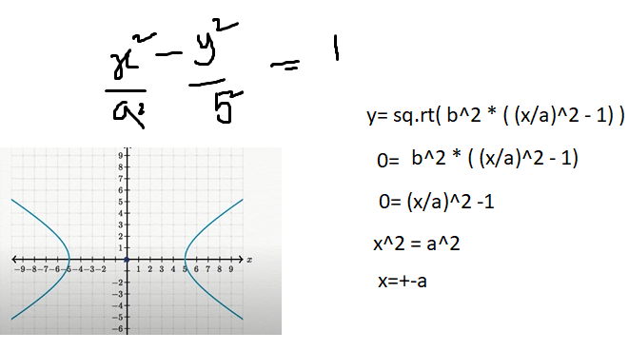

so at y=0, the two x-intercepts are x=+-a.
Since from the graph x=+-5.
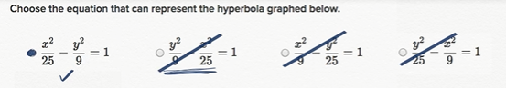

Graphing hyperbolas
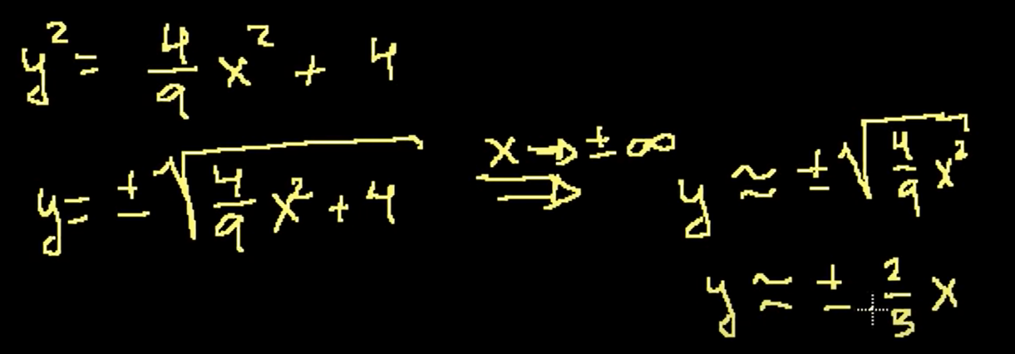

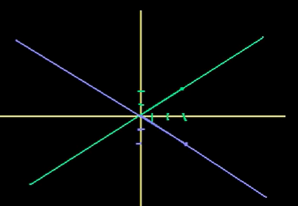

At x is zero, y is defined so up and down open hyperbola.

Foci of a hyperbola

Foci of a hyperbola from equation
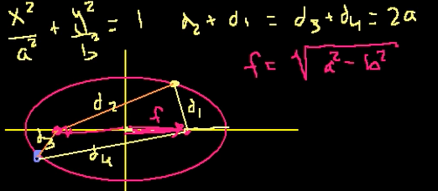

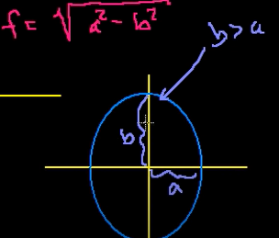
For tall and thin ellipse, the foci lies on major axis. d1+d2=2b.

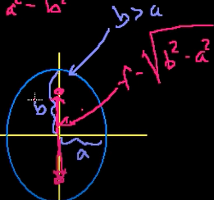

For hyperbola
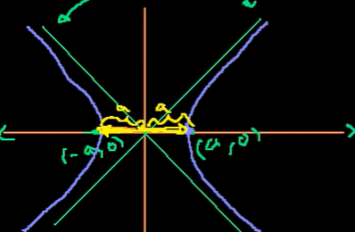

2a

Definition of hyperbola:
locus of all points where you take the differences of the distances from the two foci.
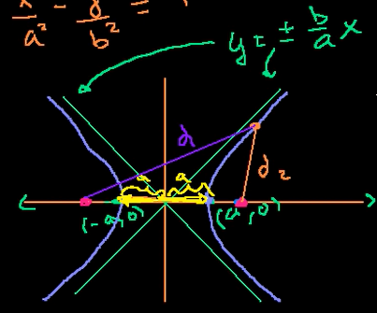
|d1-d2| = constant.

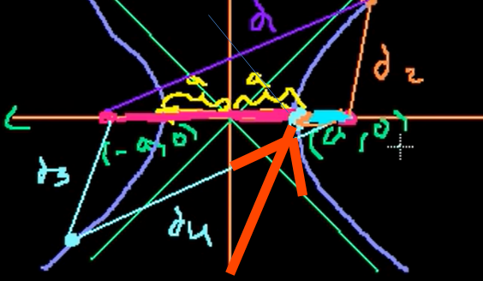

|d1-d2|=2a.
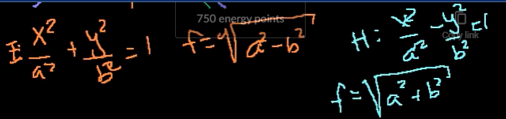
The foci formula for hyperbola

